Bilkent University | CTIS 365 (Fall 20-21) - Project Phase 1

Dr. Seyid Amjad Ali

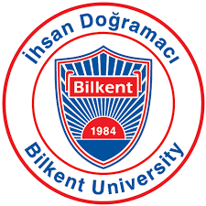

**A Comparative Study of Quality and Efficiency of Education System in Turkey**

Murat Alkan - 21601439

Erdem Sert - 21602145

**ABOUT THIS STUDY**

This study will investigate all aspects of Turkey’s education system and also the most effective education system around the world. Therefore, this study will compare Turkey’s education system with Finnish and South Korean educations systems, which are known as two of the best education systems according to OECD, by including the determinants of education quality. After analyzing the determinants, this study will compare the PISA test results among Turkey, Finland and South Korea.

There are some existing datasets, which this study can benefit from. All these existing datasets will be cleaned and prepared to be used. In addition to existing datasets, there are websites like TUIK, OECD, MEB and YOK to create new datasets. These websites will be visited to find specific education statistics about Turkey. And also, OECD, World Bank and UNESCO websites will be visited to gather statistics about Finnish education system and South Korean education system.

# I. INTRODUCTION

Education is a way of gaining knowledge and acquiring skills. To manage education, there are different education systems around the world. Some countries have a classical system but other countries have an exclusive education system to make students successful in their career. Moreover, some countries have been caring education system and they have been trying to have an effective education system because it is known that if they have an effective education system, they can also have a strong economy. In other words, an effective education system paves the way for having a sustainable and developed economy [1].

# II. QUALITY AND EFFICIENCY OF EDUCATION SYSTEM IN TURKEY

Qualification is the main term while analyzing education in a country. There are many factors to determine the quality of education system. Teaching hours, teaching methods, studying hours, exams, learning environment, students’ happiness and other education-related factors are the key to determine the quality [2], [3]. Turkey’s education system has also its special methods, factors.

## Turkey’s Education System

Turkey changes its education system frequently. In 2020, a student in Turkey is supposed to complete 4 years in primary school, 4 years in middle school, 4 years in high school. In Turkey, it is mandatory to complete these 12 years while going to a university is optional. Moreover, students have to enter LGS exam to enter a high school. Besides, students who completed their high school education have to enter TYT and AYT exams to be able to enter a university [4], [5].

## Comparison with Finnish and South Korean Education Systems

There are some advanced education systems around the world. Two of them belong to Finland and South Korea. Education System in Finland and in South Korean is completely different but both of them have been succeeding in tests [6], [7]. Finland implements a flexible education system which allows students to spend less time in schools and take less exam. On the other hand, South Korea implements a rigid education system which forces students to spend more time in schools, take more courses and take more tests throughout their education life [6], [8]. In Turkey, education system is neither flexible nor rigid. It is between those two systems but it is similar to South Korean system more because students in Turkey are required to spend more time in schools and take more competitive tests throughout students’ education life [6], [9].

When it comes to test scores, South Korea’s rigid education system and Finland’s flexible education system are more successful than Turkey’s education system. According to PISA 2018 worldwide ranking (average score of math, science and reading), South Korea got 6th place with a score of 519.7, Finland got 10th place with a score of 516.3 and Turkey got 40th place with a score of 462.7 [10].

**Figure 1**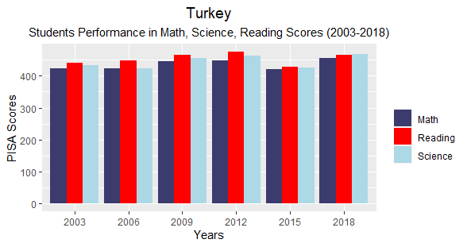

**Figure 2**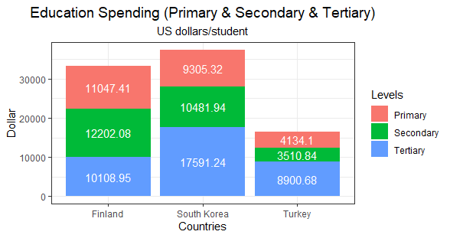

**Figure 3**

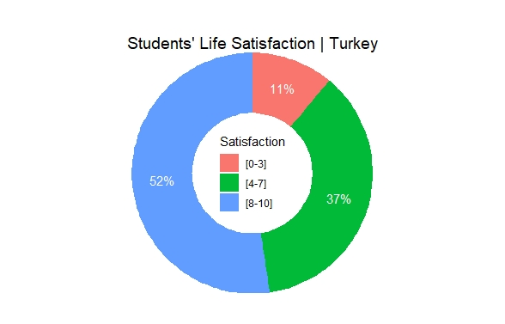**a**

**Figure 4**

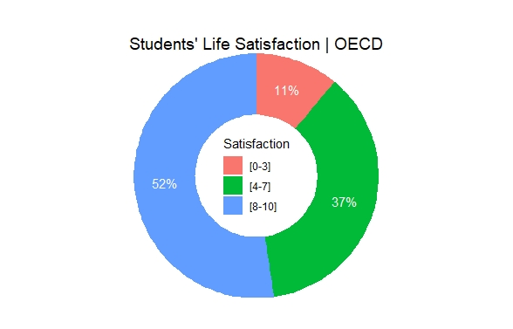

**Figure 5Figure 6**

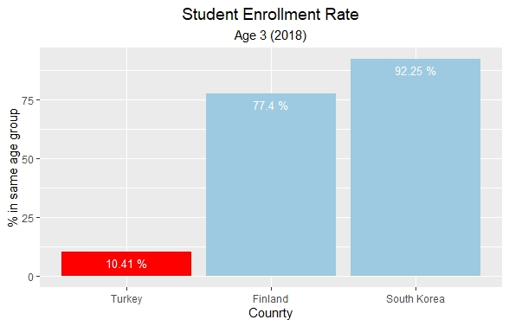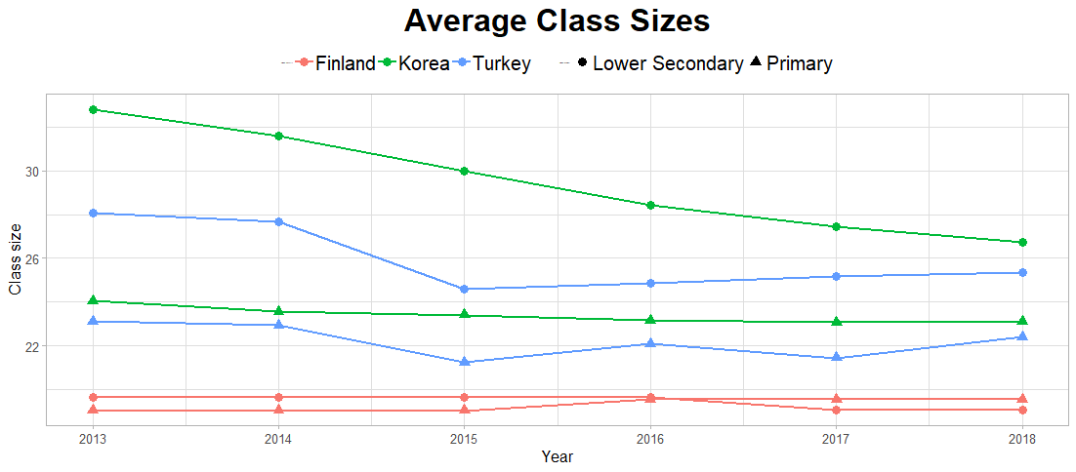

**Figure 7**

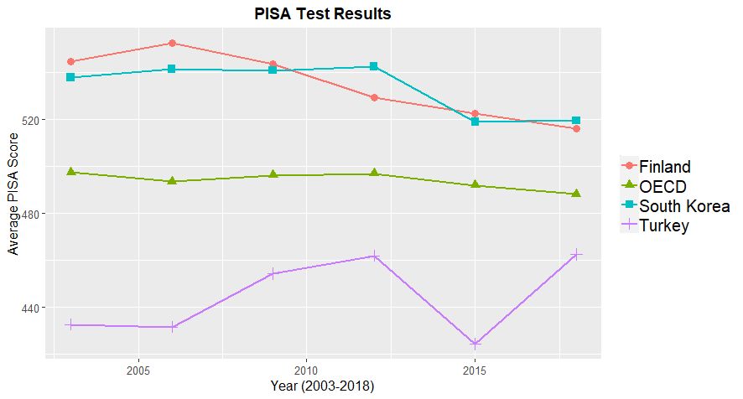

**Figure 8:**

|  |  |  |  |  |  |  |  |  |
| --- | --- | --- | --- | --- | --- | --- | --- | --- |
| Country | MIN | 25% | Mean | 75% | MAX | STD | SKW | KUR |
| Turkey | 424.3 | 431.9 | 444.6 | 460.1 | 462.7 | 16.99 | -0.01 | 1.22 |
| Finland | 516.3 | 524.3 | 534.9 | 544.7 | 552.7 | 14.28 | -0.09 | 1.49 |
| South Korea | 519.0 | 524.2 | 533.7 | 541.5 | 542.7 | 11.21 | -0.65 | 1.5 |
| OECD | 488.3 | 492.4 | 494.2 | 496.8 | 497.7 | 3.57 | -0.64 | 2.08 |

# REFERENCES

[1] E. A. Hanushek, and L. Wößmann. “The Role of Education Quality in Economic Growth,” *The World Bank*, 2017. [Online]. Available: http://documents1.worldbank.org/curated/en/260461468324885735/pdf/wps4122.pdf. [Accessed: Oct. 26, 2020].

[2] H. S. Akareem, and S. S. Hossain, “Determinants of Education Quality: What Makes Students’ Perception Different?,” Open Review of Educational Research, vol. 3, no. 1, pp. 52–67, Jan. 2016, doi:10.1080/23265507.2016.1155167.

[3] R. M. B. Bastos, “The Surprising Success of the Finnish Educational System in a Global Scenario of Commodified Education,” Revista Brasileira de Educacao, vol. 22, no. 70, pp. 802–825, 2017, doi:10.1590/S1413-24782017227040.

[4] F. Gün and G. A. Baskan, “New Education System in Turkey (4 +4 +4): A Critical Outlook,” Procedia - Social and Behavioral Sciences, vol. 131, pp. 229–235, May. 2014, doi:10.1016/j.sbspro.2014.04.109.

[5] “Turkey Overview,” *Eurydice - Europa EU*, n.d. [Online]. Available: https://eacea.ec.europa.eu/national-policies/eurydice/content/turkey_en. [Accessed: Oct. 25, 2020].

[6] A. E, Kesici, and V. K, Ceylan, “Quality of School Life in Turkey, Finland and South Korea,” International Journal of Evaluation and Research in Education, vol. 9, no. 1, pp. 100–108, Mar. 2020, doi:10.11591/ijere.v9i1.20522.

[7] Keita Takayama, et al, “Finland Has It All? Examining the Media Accentuation of ‘Finnish Education’ in Australia, Germany and South Korea*,” Research in Comparative and International Education*, vol. 8, no. 3, pp. 307–325, Jan. 2013. [Online]. Available: EBSCOhost, http://search.ebscohost.com/login.aspx?direct=true&db=eric&AN=EJ1018570&site=eds-live.

[8] Y. Lee, “Views on Education and Achievement: Finland’s Story of Success and South Korea’s Story of Decline,” *KEDI Journal of Educational Policy*, vol. 7, no. 2, pp. 379–401, Dec. 2010. [Online]. Available: EBSCOhost, http://search.ebscohost.com/login.aspx?direct=true&db=edo&AN=57715550&site=eds-live.

[9] “The Turkish education system,” *OECD*, n.d. [Online]. Available: https://www.oecd-ilibrary.org/sites/71ee93b4-en/index.html?itemId=/content/component/71ee93b4-en. [Accessed: Oct. 24, 2020].

[10] “PISA 2018 results,” *OECD*, n.d. [Online]. Available: https://www.oecd.org/pisa/publications/pisa-2018-results.htm. [Accessed: Oct. 24, 2020].